CDAC MUMBAI

**Concepts of Operating System Assignment 2**

**Part A**

**What will the following commands do?**

* echo "Hello, World ! " :- It will print "Hello, World ! " in terminal
* name="Productive" :- This assign the string
* touch file.txt :- It is used to create an empty file
* ls –a :- It is used to list out all files and directories including hidden files
* rm file.txt :- it is used to removes file file.txt
* cp file1.txt file2.txt :- it is used to copy all the content of file1 into file2, if it does not exist it will create a new file.
* mvfile.txt /path /to /directory/:- move the file into specified directory
* chmod 755 script.sh :- it gives permission to read , write ,execute permission to the owner.
* grep"pattern"file.txt :- searches for a pattern in a file
* kill PID :- It is used to terminate running process
* catfile1.txtfile2.txt|sort| uniq :- concatenate file1 and file2 and sort sorts the combined content, and removes duplicate lines.
* ls -l |grep"^d" :- Lists files in long format and then filters the output to show only directories
* grep-r "pattern" /path /to/ directory/ :- searches for a string pattern
* catfile1.txt file2.txt|sort|uniq–d :- concatenate file1 and file2
* chmod 644 file.txt :- gives permission to file which means owner can read ,write and other only read it
* cp-rsource\_directory destination\_directory :- copy the entire content of source directory to destination directory.
* find /path /to / search-name "\*.txt" :- Searches for all files with the extension within the specified directory and its subdirectories.
* chmod u+x file.txt :- sets permission for execte to owner
* echo $PATH :- prints the value of current value variable

# Part B

## Identify True or False:

1. **ls** is used to list files and directories in a directory. - **TRUE**
2. **mv** is used to move files and directories. -**TRUE**
3. **cd** is used to copy files and directories. - **FALSE**
4. **pwd** stands for "print working directory " and displays the current directory. - **TRUE**
5. **grep** is used to search for patterns in files. - **TRUE**
6. **Chmod 755 file.txt** gives read , write , and execute permissions to the owner, and read and execute permissions to group and others. - TR**UE**
7. **mkdir –p directory1/directory2** creates nested directories , creating directory2 inside directory1 if directory1 does not exist. - **TRUE**
8. **rm – rf file.txt** deletes a file forcefully without confirmation - **TRUE**

## IdentifytheIncorrectCommands:

1. chmodx is used to change file permissions. :- correct command is chmod
2. cpy is used to copy files and directories. :- correct command is cp
3. mkfile is used to create a new file. :- correct command is touch
4. catx is used to concatenate files. :- correct command is cat
5. rn is used to rename files. :- correct command is mv

# Part C

**Question 1:** Write a shell script that prints "Hello, World!" to the terminal.

C:\Users\sejus\AppData\Local\Packages\MicrosoftWindows.Client.CBS_cw5n1h2txyewy\TempState\ScreenClip\{F13B0170-AA62-4B45-A806-C7E7D73E7B63}.png

**Question 2:** Declare a variable named "name" and assign the value "CDAC Mumbai" to it. Print the value of the variable.

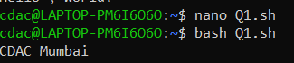C:\Users\sejus\AppData\Local\Packages\MicrosoftWindows.Client.CBS_cw5n1h2txyewy\TempState\ScreenClip\{05FC2C77-B1B5-47C7-9296-1AD2A822D4AF}.png

**Question 3:** Write a shell script that takes a number as input from the user and prints it.

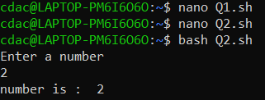 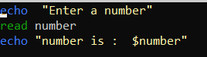

**Question 4:** Write a shell script that performs the addition of two numbers (e.g., 5 and 3) and prints the result.

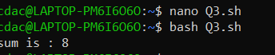 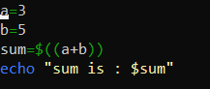

**Question 5:** Write a shell script that takes a number as input and prints "Even" if it is even, otherwise prints "Odd".

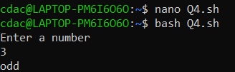 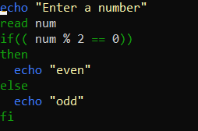

**Question 6:** Write a shell script that uses a for loop to print numbers from 1 to 5.

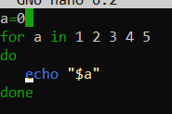 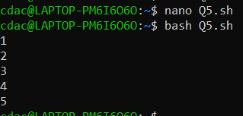

**Question 7:** Write a shell script that uses a while loop to print numbers from 1 to 5.

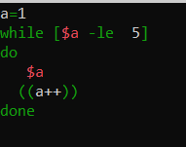 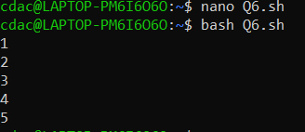

**Question 8:** Write a shell script that checks if a file named "file.txt" exists in the current directory. If it does, print "File exists", otherwise print "File does not exist".

 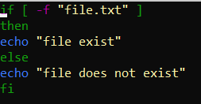

**Question 9:** Write a shell script that uses the if statement to check if a number is greater than 10 and prints a message accordingly.

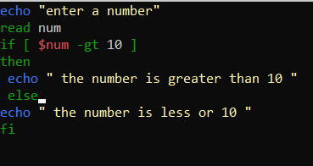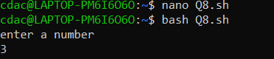

**Question 10:** Write a shell script that uses nested for loops to print a multiplication table for numbers from 1 to 5. The output should be formatted nicely, with each row representing a number and each column representing the multiplication result for that number.

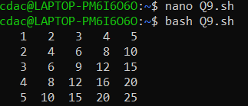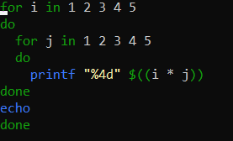

**Question 11:** Write a shell script that uses a while loop to read numbers from the user until the user enters a negative number. For each positive number entered, print its square. Use the break statement to exit the loop when a negative number is entered.

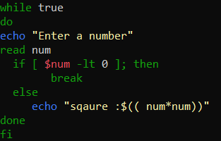

**Part E**

1. Consider the following processes with arrival times and burst times:

|Process| ArrivalTime|BurstTime|

| | | |

|P1 |0 |5 |

|P2 |1 |3 |

|P3 |2 |6 |

Calculate the average waiting time using First-Come , First-Served (FCFS) scheduling.

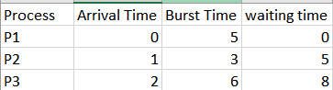



Gantt chart

Avg waiting time= 0+5+8 =13/3= 4.3

1. Consider the following processes with arrival times and burst times:

|Process|ArrivalTime|BurstTime|

| | | |

|P1 |0 |3 |

|P2 |1 |5 |

|P3 |2 |1 |

|P4 |3 |4 |

Calculate the average turn around time using Shortest Job First (SJF)scheduling.

Ans:-

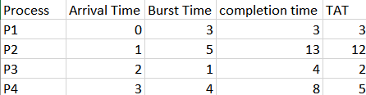

Gantt Chart 

Average TAT=43+12+2+5​=422​=5.5

3. Consider the following processes with arrival times, burst times ,and priorities(lowernumber indicates higher priority):

|Process|ArrivalTime|BurstTime|Priority|

|  |  |  |  |  |
| --- | --- | --- | --- | --- |
| | | | | | | | | | |
| |P1 | |0 | |6 | |3 | | |
| |P2 | |1 | |4 | |1 | | |
| |P3 | |2 | |7 | |4 | | |
| |P4 | |3 |  | |2 | | |

Calculate the average waiting time using Priority Scheduling

Ans:

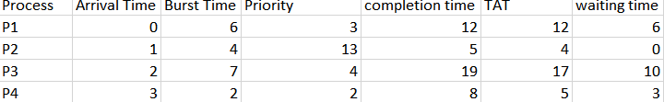



Average WT=46+0+10+3​=419​=4.75

.

1. Consider the following processes with arrival times and burst times , and the time quantum for Round Robin scheduling is 2 units:

|Process|ArrivalTime|BurstTime|



| | | |

|P1 |0 |4 |

|P2 |1 |5 |

|P3 |2 |2 |

|P4 |3 |3 |

Calculate the average turn around time using Round Robin scheduling.

Ans :

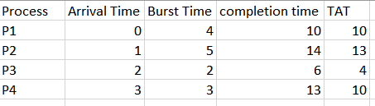



Average TAT=410+13+4+10​=437​=9.25